MHAA-USNR System

A Dynamic Website for Alumni Association

**By team**

Antivirus

*MHAA-USNR System*

*User-Manual*

|  |  |  |
| --- | --- | --- |
| **Team Members** | **Course** | **Instructor** |
| Shada Khanneh | CSIT 515  Software Engineering and Reliability | Dr. Hubert A. Johnson |
| Aseel Aloweiwi |
| Mira Boulos |
| Iman Almutairi |
| Amal Alamri |

December 3, 2020

Document Revision History

|  |  |  |  |
| --- | --- | --- | --- |
| **Name** | **Date** | **Reason for Changes** | **Version** |
| Shada Khanneh | December 3, 2020 | First Release | 1.0 |
| Iman Almutairi  Amal Alamri | December 11, 2020 | Add contact  Update | 1.3 |
| Iman Almutairi  Amal Alamri | December 12, 2020 | Add contact  Update  Change | 1.4 |
| Iman Almutairi  Amal Alamri | December 13, 2020 | Add contact  Update  Change | 1.4 |
| Aseel Aloweiwi | December 14,2020 | Review | 1.6 |
| Shada Khanneh | December 14,2020 | Final Review | 1.7 |

Table of Content

1 Introduction 5

1.1 Purpose of the System 5

1.2 Project Goals 5

1.3 Purpose of the Current Document 5

2 How to launch the system 6

3 User’s Manual 9

3.1 How to Navigate the System 9

3.2 View the Association Mission and Motto 10

3.3 View the History 10

3.4 View the News 11

3.5 View Events 12

3.6 Meet the Association Officers 15

3.7 Register to an event 16

3.8 Donate to the Association 20

4 Officers’ Manual 24

4.1 Login to the system 24

4.2 Add and Delete News 25

4.2.1 Delete a News Record 25

4.2.2 Add a News Record 28

4.3 Add and Delete Upcoming Event 30

4.3.1 Delete an Upcoming Event 30

4.3.2 Add an Upcoming Event 32

4.4 Add and Delete Previous Event 35

4.4.1 Delete a Previous Event 35

4.4.2 Add a Previous Event 36

4.5 Logout from the system 38

5 Administrator Manual 39

5.1 Login to the System 39

5.2 Change page content 40

5.3 Change Contact Us 41

5.4 Logout from the system 41

Table of Figures

Figure 1 General tab on XAMPP 6

Figure 2 Services tab on XAMPP 7

Figure 3 Volumes tab on XAMPP 7

Figure 4 PHPMyAdmin 8

Figure 5 Navigation Bar(A) and Bottom Section (B) 9

Figure 6 Homepage 10

Figure 7 History Page 10

Figure 8 News Page 11

Figure 9 News Information 11

Figure 10 Events Page 12

Figure 11 Upcoming-Event Information 13

Figure 12 Previous-Event Information 14

Figure 13 Officers Page 15

Figure 14 Events Page 16

Figure 15 Upcoming-Event Information 17

Figure 16 Event Registration Form 18

Figure 17 Payment Information Form 18

Figure 18 Event Registration Confirmation 19

Figure 19 Events Page 20

Figure 20 Upcoming-Event Information 21

Figure 21 Payment Information Form 22

Figure 22 Donation Confirmation 23

Figure 23 Officers Page 24

Figure 24 News Page Officers-View 25

Figure 25 Delete Record Confirmation Message 26

Figure 26 Alumni News Removed Record 27

Figure 27 Alumni News Officers-View 28

Figure 28 News Add Form 29

Figure 29 Events Page Officers-View 30

Figure 30 Delete an Upcoming Event 31

Figure 31 Event Page Officers-View 32

Figure 32 Add Upcoming-Event Form 33

Figure 33 Event Page Officers View 34

Figure 34 Event Page Officers-View 35

Figure 35 Add Previous-Event Record 36

Figure 36 Add a previous Event Form 37

Figure 37 Logout 38

Figure 38 Login box 39

Figure 39 Home Page Form 40

Figure 40 Contact Us Form 41

# Introduction

“MHAA-USNR” system is a dynamic website designed and built to serve the needs of the Maggotty High Alumni Association - US Northern Region. The “MHAA-USNR” this website aims to facilitate the Association’s targeted objectives and provide the website’s visitors/users with an easy and simple way to benefit from the organization’s offered services.

## Purpose of the System

The Maggotty High Alumni Association website is available for public use through the web interface. Users can get updated regarding the school’s news, register for events, and make donations. The organization’s officers of the Maggotty High School Alumni association have control over the system. Officers can create events and update the school news. The system delivers its users an easy payment and donation process by providing most known payment methods (credit cards, debit card and PayPal). The website displays a background history of the school and provides visitors with information on how the donations contribute to developing a better learning environment for the school’s students.

## Project Goals

This project offers a user-friendly website that enables its users to easily navigate through the website and utilize the provided features of the system such as event registration and fund donations. Another goal of this project is to offer the school’s officers the ability to create events and add news.

## Purpose of the Current Document

This user-manual will include detailed instruction for users to aid them successfully complete a specific service the “MHAA-USNR” system offers.

# How to launch the system

**To run the MHAA-USNR website, follow these steps:**

1. Download XAMPP software to your computer. (Here is a link where you can download it: <https://www.apachefriends.org/index.html>).
2. Open the XAMPP program and choose General tab. Click on Start button as shown in Figure (1).

Figure 1 General tab on XAMPP

1. Click on Services tab and click on Start button to activate Apache and MySQL as shown in Figure (2).

Figure 2 Services tab on XAMPP

1. Click on Volumes tab and click on Mount button.

Figure 3 Volumes tab on XAMPP

1. Click on import on the main menu bar as shown in the Figure (4).
2. Copy the folder “Alumni” that you will find in the system package.
3. Go to XAMPP folder and then to “htdocs” and paste Alumni folder.
4. In your browser (preferably Google chrome) enter “localhost:8080/phpmyadmin” in the URL input field.
5. Click on “Choose file” button and choose “maggotty.sql” from the Alumni Folder that is placed in htdocs to upload the database.
6. Click on “Go” button on the bottom right corner. The database will automatically upload.
7. Open a new browser and go to this URL [localhost:8080/Alumni](http://localhost:8080/Alumni/) .The System will start and show the Home page.

Figure 4 PHPMyAdmin

# User’s Manual

## How to Navigate the System

1. Navigation Bar
2. The **Navigation Bar** is located at the top of the screen. **Item (A) in figure (5)**.
3. Use the navigation bar by clicking at the page name you want to navigate to.
4. Bottom Section
5. The Bottom Section is located at the bottom of the screen. **Item (B) in figure (5)**.
6. Use the Bottom Section to:

* Navigate to pages listed in the links by clicking at the page name you want to navigate to.
* To view the association Contact us information (phone number email address and location)
* to navigate to the FAQs where you can find and answer to a problem or a concern you are having.

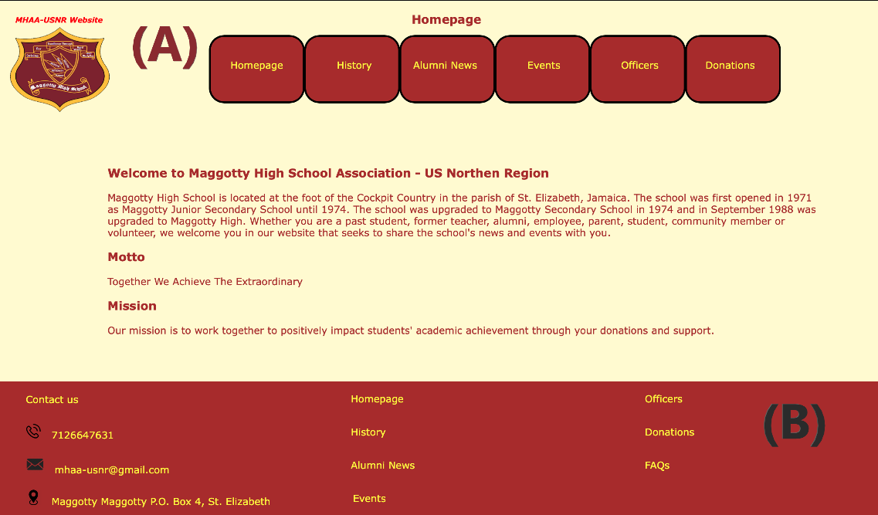

Figure 5 Navigation Bar(A) and Bottom Section (B)

## View the Association Mission and Motto

To view the association mission and motto and read about it navigate to the Homepage using the Navigation Bar or the Bottom Section as shown in figure (6) below:

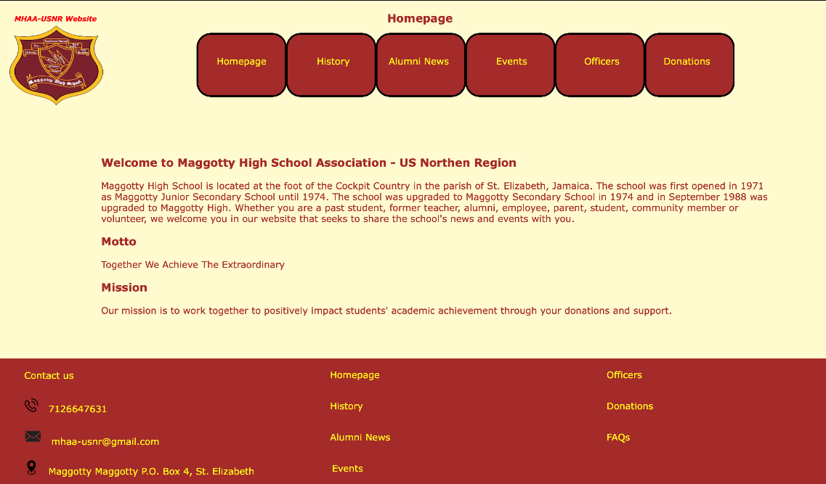

Figure 6 Homepage

## View the History

To view the association mission and read about it navigate to the History page using the Navigation Bar or the Bottom Section as shown in figure (7) below:

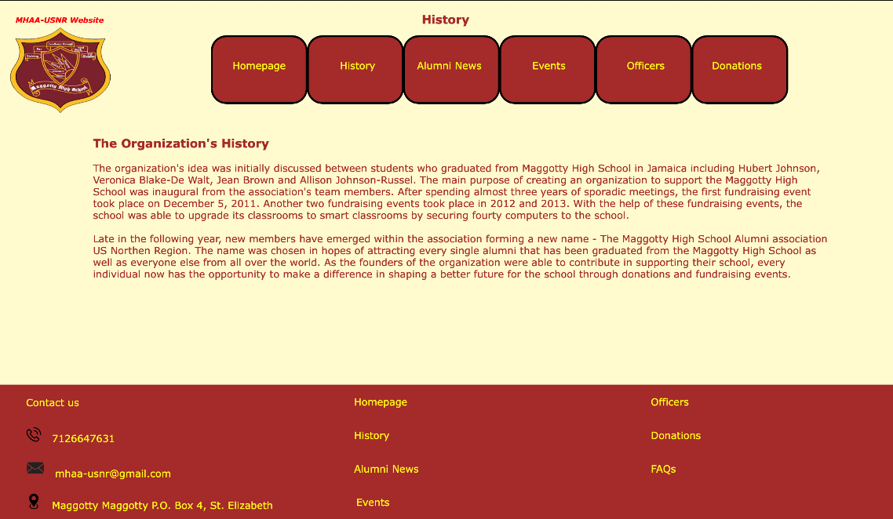

Figure 7 History Page

## View the News

to view any News posted by the association follow these steps

1. Navigate to the Alumni News page using the Navigation Bar or the Bottom Section.

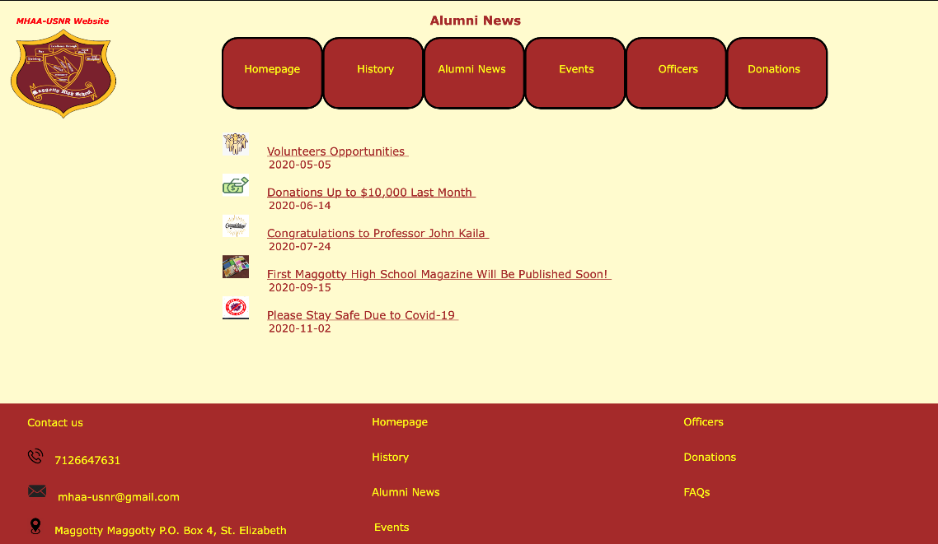

Figure 8 News Page

1. In the Alumni News page click on the News record you wish to read more about
2. Once in the News information page you can read the news content and view any related images to that News.

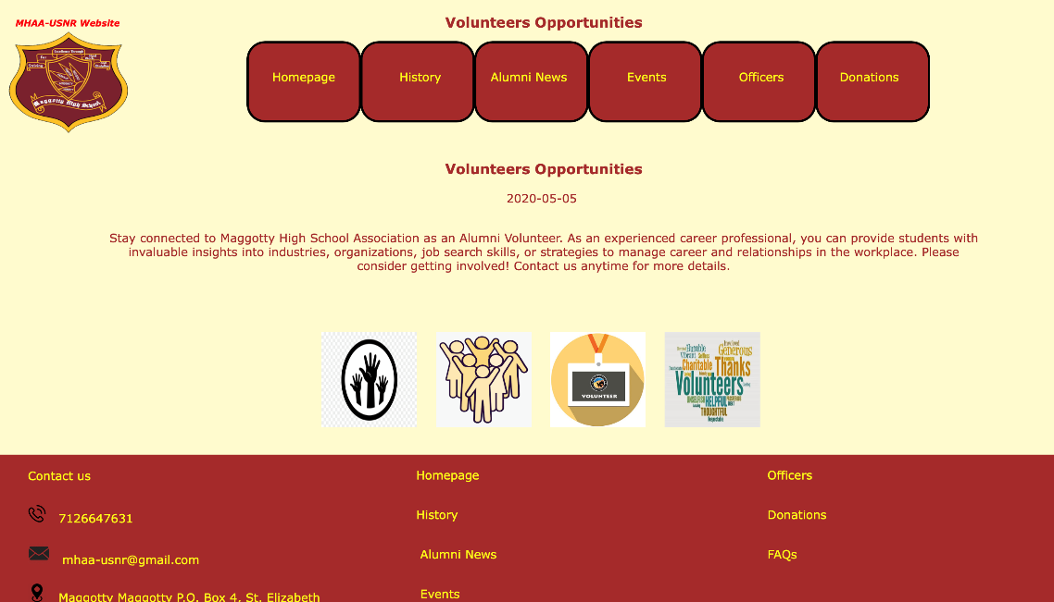

Figure 9 News Information

## View Events

to view any Events previous or upcoming posted by the association follow these steps

1. Navigate to the Events page using the Navigation Bar or the Bottom Section.

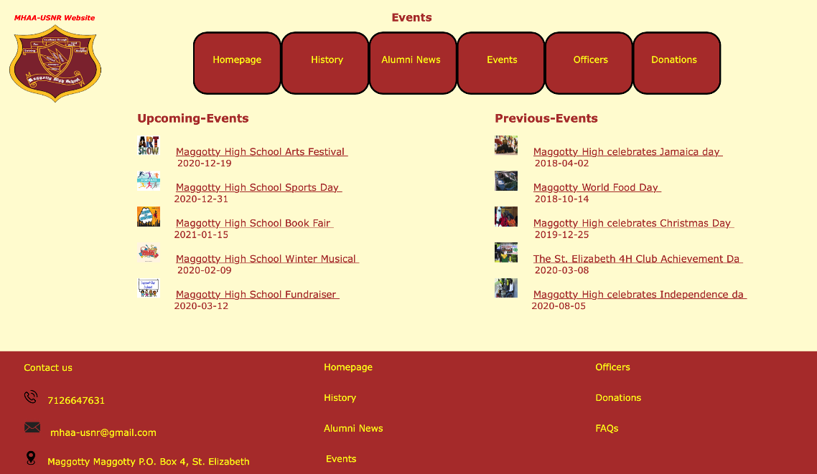

Figure 10 Events Page

1. to view an Upcoming-Event click on the Upcoming-Event record you wish to read more about from the records listed under the title Upcoming-Events shown in figure (11).
2. once in the Upcoming-Event information page you can read and learn more about that event
3. You can also register to an upcoming-event by clicking the button “Register to this Event” that will appear in the Upcoming-Event information page. As shown in the figure (12). to learn more about event registration go to section (‎3.7 Register to an event).

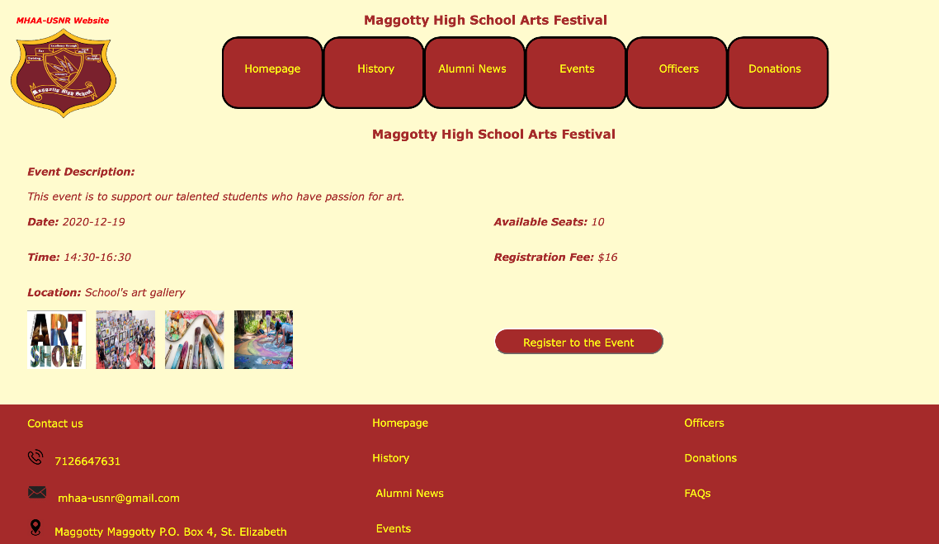

Figure 11 Upcoming-Event Information

1. to view a Previous-Event click on the Previous-Event record you wish to read more about from the records listed under the title Previous-Events shown in figure (10).
2. once in the Previous-Event information page you can read and learn more about that event and see any related images to the Event. As shown in figure (12).

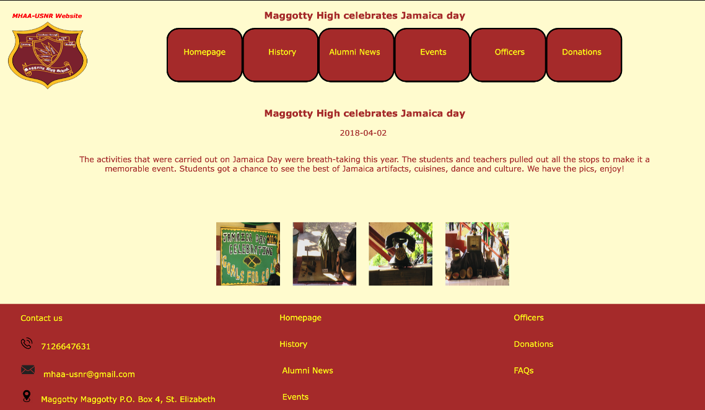

Figure 12 Previous-Event Information

## Meet the Association Officers

To learn about who is running the association and meet its members, follow these steps:

1. Navigate to the Officers page using the Navigation Bar or the Bottom Section.
2. Once in the Officers page you can see the Officers’ names, titles, images, role, and contact information. As shown in figure (13).

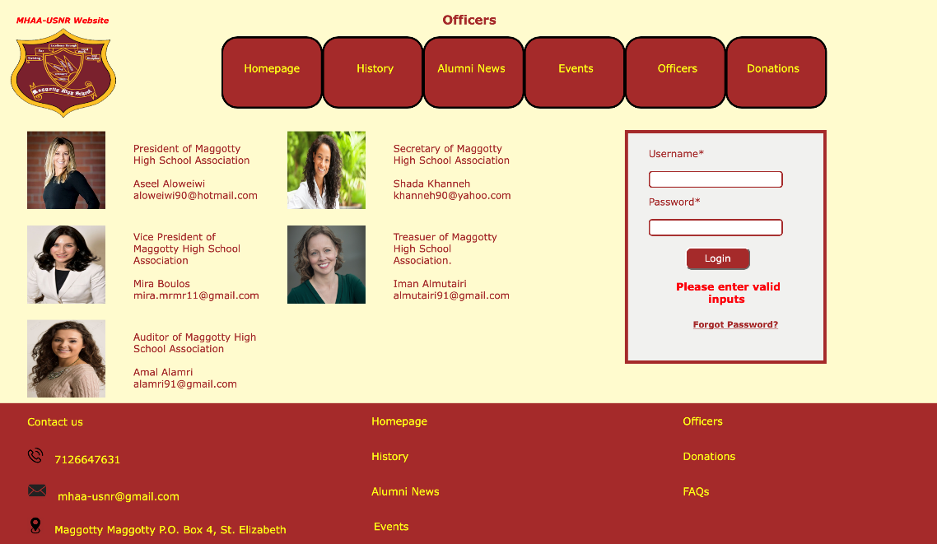

Figure 13 Officers Page

## Register **to** an event

the MHAA-USNR website offers the ability to register to an Upcoming-Event and pay the registration fee using e-payments.

**To register to an Upcoming-Event follow these steps:**

1. Navigate to the Events page using the Navigation Bar or the Bottom Section.



Figure 14 Events Page

1. From the records listed under the title Upcoming-Events click on the Upcoming-Event you wish to register to. As shown in figure (14).
2. Once in the Upcoming-Event information page you will see a “Register to this Event” button:

* If the Upcoming-Event has seats available (Available seats is not showing “0”) and the Upcoming-Event has not expired (Date shows an upcoming date). The button will appear in burgundy color and you can click on it.
* If the button appears in gray, this means the events has no available seats or the event has expired, and you will not be able to click on the button.

1. If the “Register to this Event” button appears active (burgundy) click on it to go to the registration form. As shown in figure (15).



Figure 15 Upcoming-Event Information

1. Once in the “Event Registration” form fill all mandatory fields marked with an asterisk and press the “Register” button. As shown in figure (16).

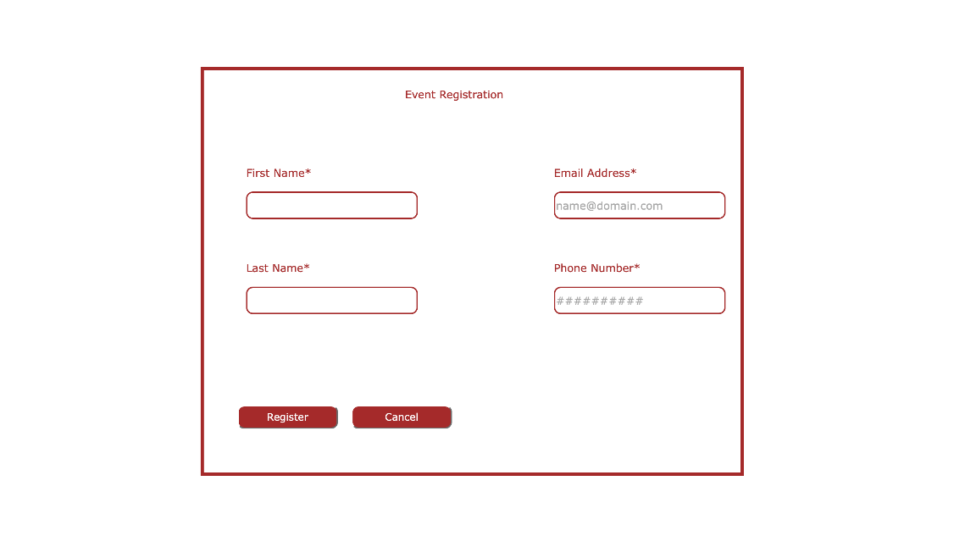

Figure 16 Event Registration Form

1. After you press “Register” you will be directed to the “Payment Information” form, fill all the mandatory fields marked with an asterisk and press the “Pay” button. As shown in figure (17).

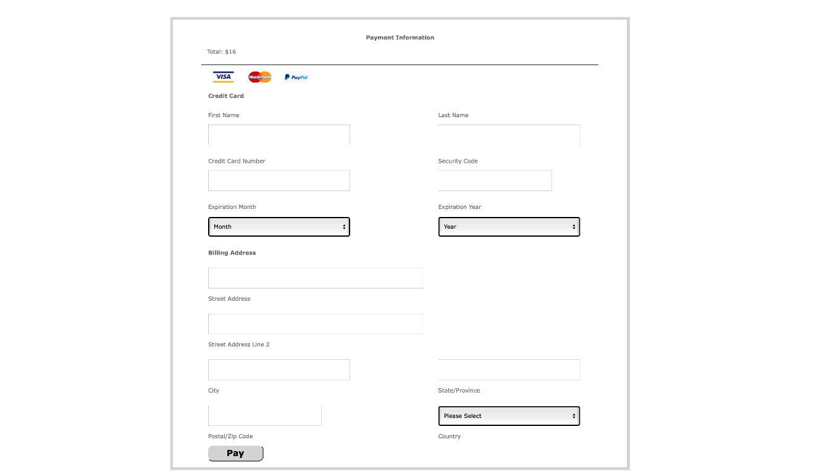

Figure 17 Payment Information Form

1. Once your payment been accepted you will be directed to the Event Registration Confirmation page. We advise you print this screen and keep a copy of your Registration number.
2. A confirmation email will be sent to the email address you entered in the “Event Registration Form”.

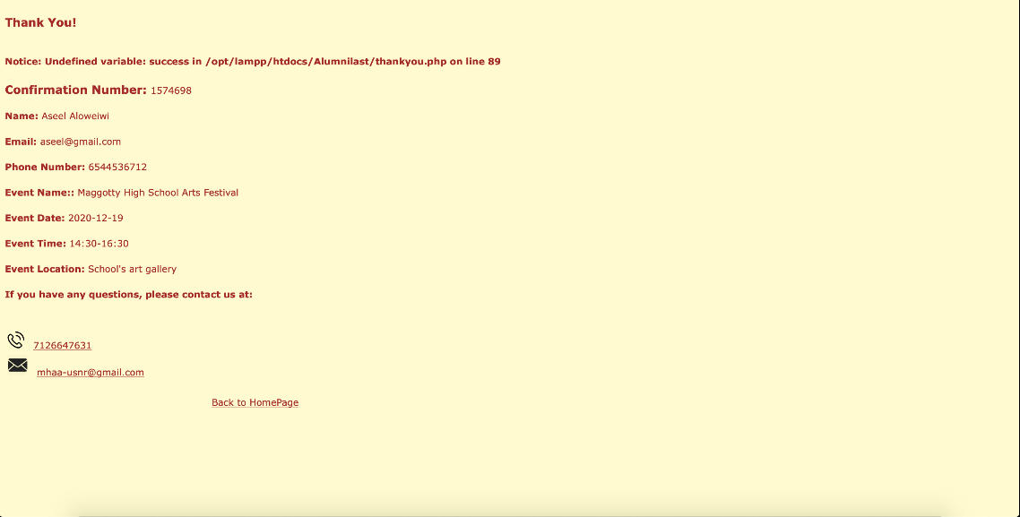

Figure 18 Event Registration Confirmation

## Donate to the Association

If you wish to help the association with a fund donation the MHAA-USNR website offers an easy way to do so with the ability to pay using e-payments.

To make a fund donation follow these steps:

1. Navigate to the Donations page using the Navigation Bar or the Bottom Section.

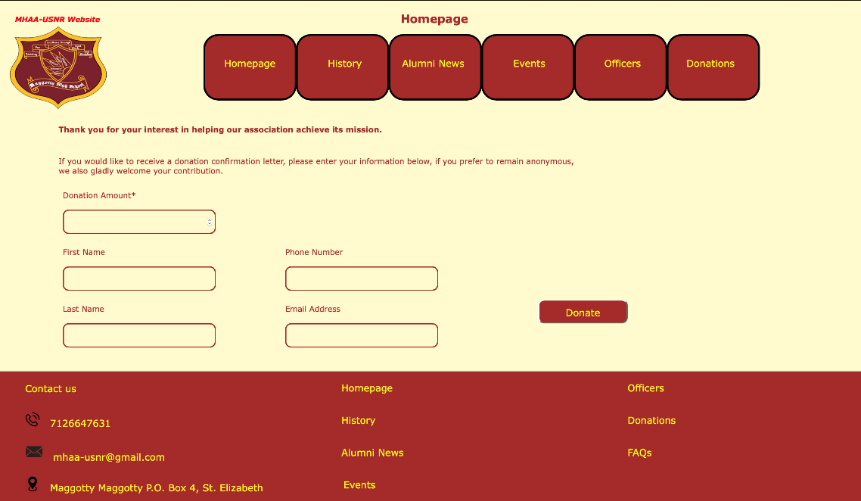

Figure 19 Events Page

1. Once in the Donations page enter the amount of funds you wish to donate in the specified filed. As shown in figure (20).
2. You are only required to fill this filed if you wish to keep your donation anonymous. You can fill the other fields if you wish to receive a thank you email and be added to the association’s philanthropist list.

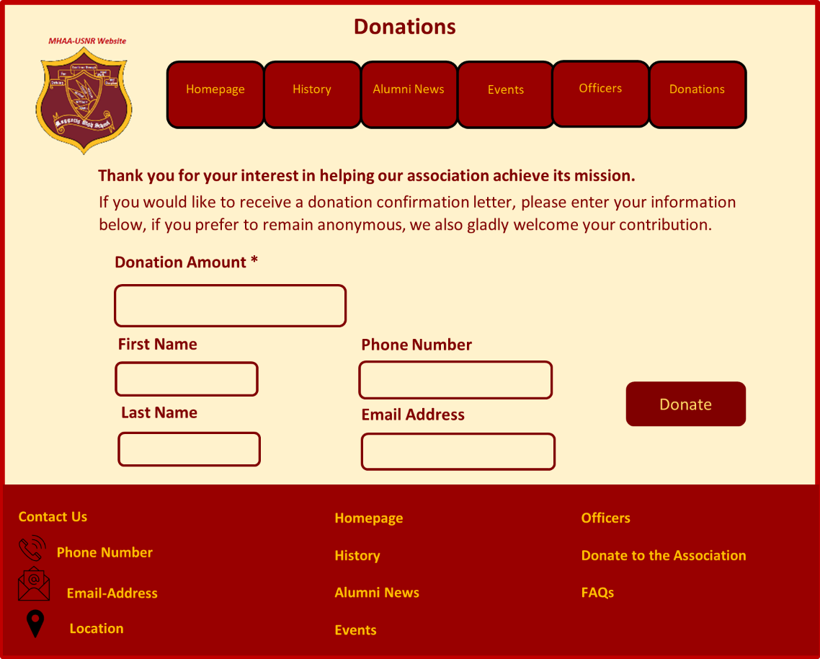

Figure 20 Upcoming-Event Information

1. After you enter your fund amount press the “Donate” button to go to the “Payment Information” form.
2. In the “Payment Information” form, fill all the mandatory fields marked with an asterisk then press the “Pay” button. As shown in figure (21).



Figure 21 Payment Information Form

1. Once your payment been accepted you will be directed to the Donation Confirmation page. We advise you print this screen and keep a copy of your Donation number.
2. If you entered an email address in the Donations page a thank you email will be sent to your email.

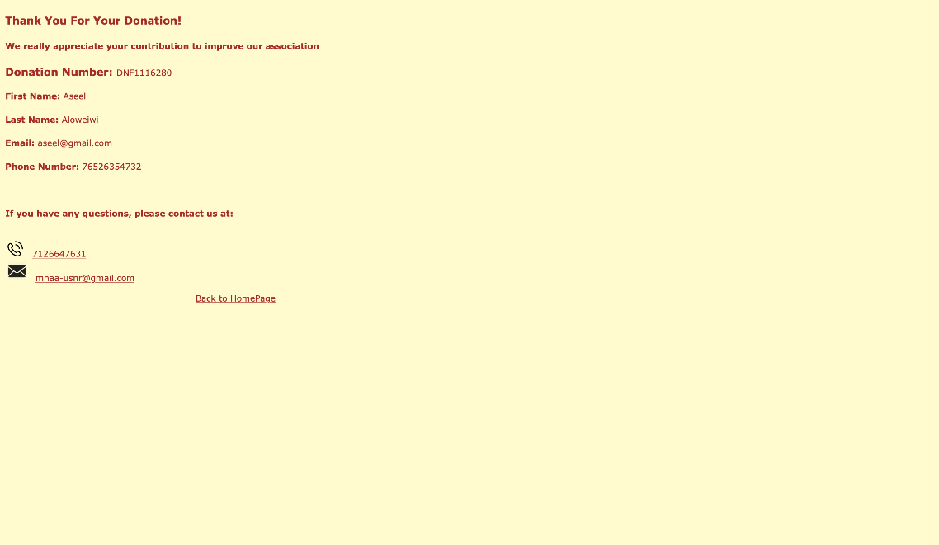

Figure 22 Donation Confirmation

# Officers’ Manual

## Login to the system

Officers must login to the system using their unique preset username and password, to gain officer privileges, that allows them to add and delete records on the Alumni News and Events page.

**To login to the MHAA-USNR system follow these steps:**

1. Navigate to the Officers page using the Navigation Bar or the Bottom Section.
2. Once in the Officers page you can see a login box, enter your preset username and password then click the “Login” button.
3. Once you successfully login you will be directed to the Homepage and you will see a welcome message containing your name. As shown in figure (23).

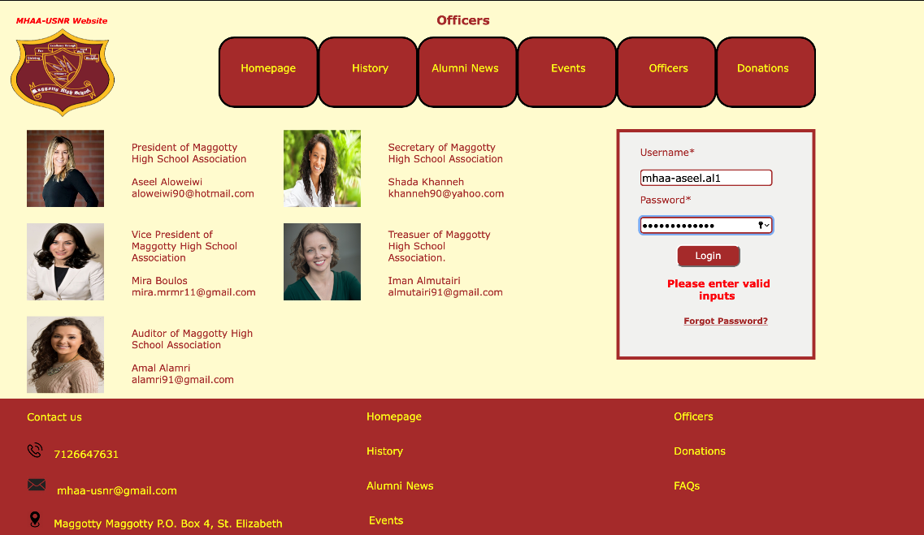

Figure 23 Officers Page

## Add and Delete News

### Delete a News Record

1. From the Navigation Bar click on the Alumni News tab.
2. Click the “delete” button next to the record you wish to delete. As shown in figure (24).

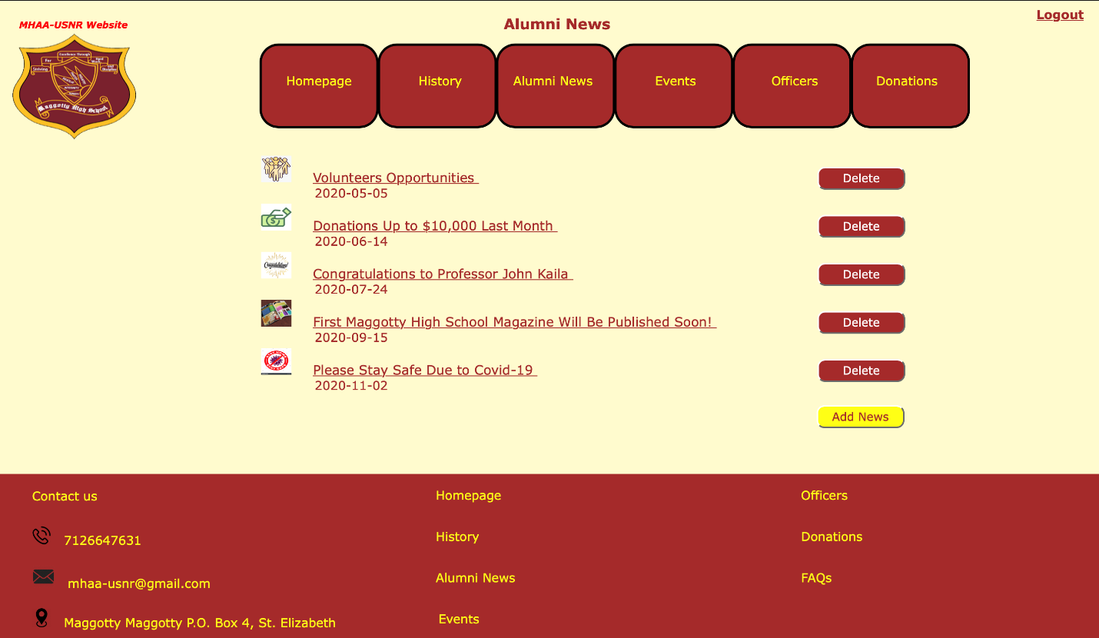

Figure 24 News Page Officers-View

1. From the confirmation message that will show, press “Yes” to confirm the deletion. As shown in figure (25).

Figure 25 Delete Record Confirmation Message

1. After the deletion confirmation message appear, refresh the page to see the reflected changes.

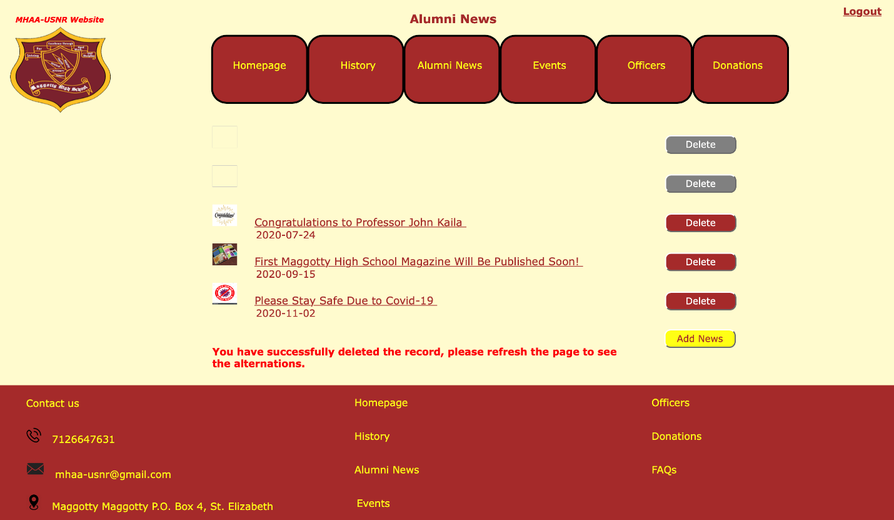

Figure 26 Alumni News Removed Record

### Add a News Record

1. From the Navigation Bar click on the Alumni News tab. As shown in figure (27).
2. Click on “Add News” button.



Figure 27 Alumni News Officers-View

1. From the “Add Form”, choose the row number for the record you wish to insert or replace.
2. Fill all the mandatory fields.
3. If you wish to attach an image to this record, follow the following steps:
4. Copy the desired image.
5. Go to XAMPP folder in your computer.
6. Open “htdocs” folder.
7. Open “Alumni” folder.
8. Paste the image.
9. Click on “Add” button. Figure (28) shows the Add Form.
10. After the Adding Record confirmation message appear, refresh the page to see the reflected changes.

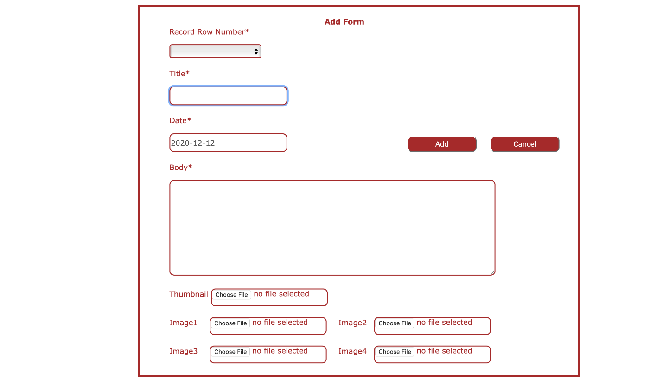

Figure 28 News Add Form

## Add and Delete Upcoming Event

### Delete an Upcoming Event

1. Go to the navigate bar and click Event tab. As shown in figure (29).
2. Click on the “Delete” button next to the upcoming event you wish to delete.
3. From the confirmation message that will show, press “Yes” to confirm the deletion.

Figure 29 Events Page Officers-View

1. After the deletion confirmation message appear, refresh the page to see the reflected changes as shown in Figure (30).

Figure 30 Delete an Upcoming Event

### Add an Upcoming Event

1. From the Navigation Bar click on the Events tab.
2. Click on “Add Upcoming Event” button as shown in Figure (31).
3. Choose the record row number that you wish to add the record in.

Figure 31 Event Page Officers-View

1. Complete all the mandatory fields.
2. If you wish to attach an image to this record, follow the following steps:
3. Copy the desired image.
4. Go to XAMPP folder in your computer.
5. Open “htdocs” folder.
6. Open “Alumni” folder.
7. Paste the image.
8. Click on “Add” button. Figure (32) shows the “Add Upcoming Event” Form.

Figure 32 Add Upcoming-Event Form

1. After the adding confirmation message appear, refresh the page to see the reflected changes. Figure (33) shows the message after a successful addition.

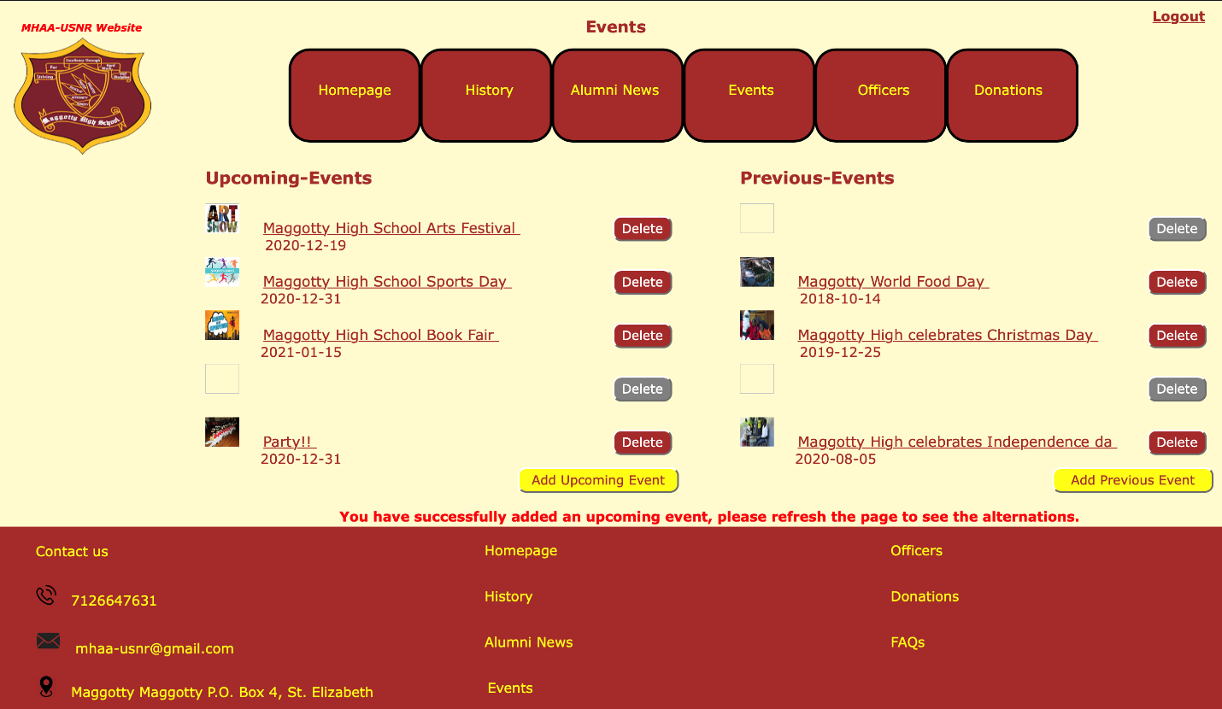

Figure 33 Event Page Officers View

## Add and Delete Previous Event

### Delete a Previous Event

1. Go to the navigate bar and click Event tab.
2. Click on the “Delete” button next to the previous event you wish to delete.
3. From the confirmation message that will show, press “Yes” to confirm the deletion.
4. After the deletion confirmation message appear, refresh the page to see the reflected changes as shown in Figure (34).

Figure 34 Event Page Officers-View

### Add a Previous Event

1. From the Navigation Bar click on the Events tab.
2. Click on “Add Previous Event” button.
3. Choose the record row number that you wish to add the record in.

Figure 35 Add Previous-Event Record

1. Complete all the mandatory fields.
2. If you wish to attach an image to this record, follow the following steps:
3. Copy the desired image.
4. Go to XAMPP folder in your computer.
5. Open “htdocs” folder.
6. Open “Alumni” folder.
7. Paste the image.
8. Click on “Add” button. Figure (36) shows the “Add” form.
9. After the adding confirmation message appear, refresh the page to see the reflected changes

Figure 36 Add a previous Event Form

## Logout from the system

1. Click on logout link in the up-right corner. As shown in Figure (37).

Figure 37 Logout

# Administrator Manual

## Login to the System

1. Click on “Event” tab from the navigation bar.
2. Enter your username and password on the login box shown in Figure (38). Click on login button.

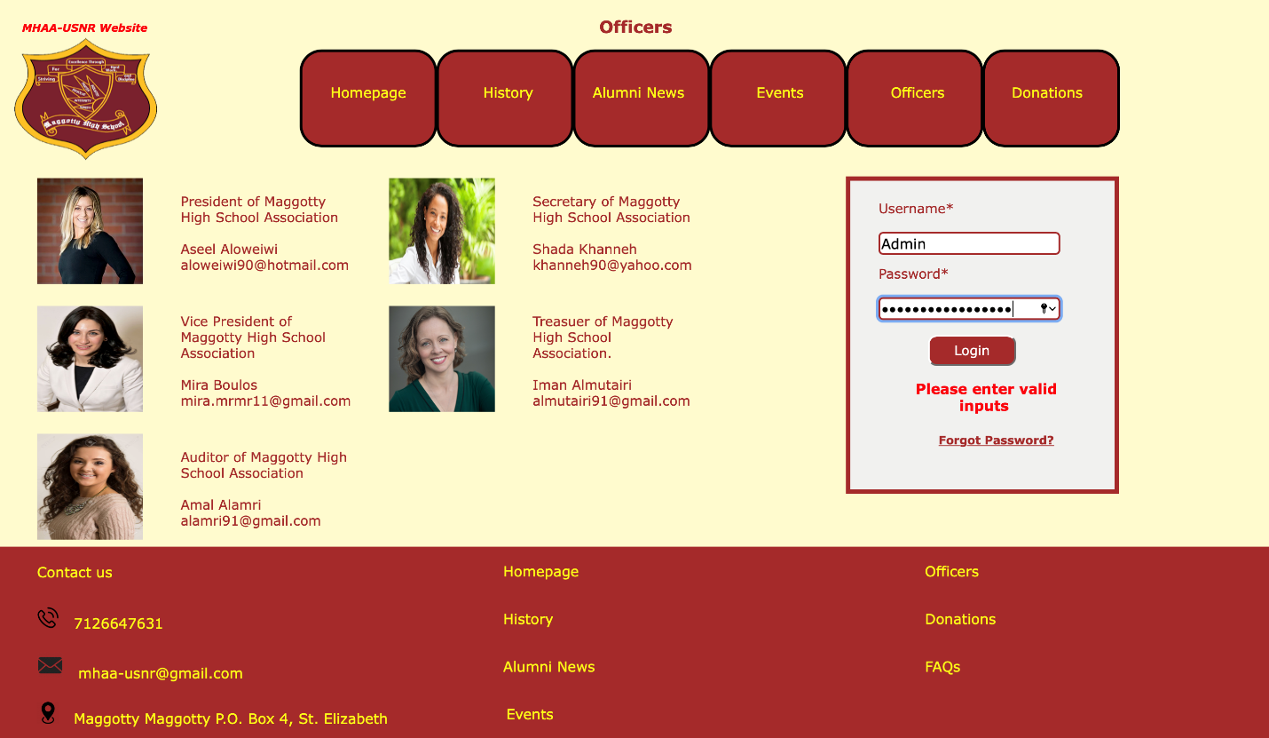

Figure 38 Login box

## Change page content

1. Login as specified in (‎5.1 Login to the System).
2. Click on the page tab from the navigation bar you wish to make changes to it.
3. Click on the “Change” button appear on that page.
4. Fill all the mandatory fields and click on “Submit” button. Figure (39) shows the Home Page form.
5. Refresh the page to see the reflected changes.

Figure 39 Home Page Form

## Change Contact Us

1. Login as specified in (‎5.1 Login to the System).
2. Click on the Homepage tab from the navigation bar.
3. Click on the “Change Contact Us” button in the right-bottom corner.
4. Fill all the mandatory fields in “Contact Us” Form and click on “Submit” button. Figure (40) shows “Contact Us” Form.
5. Refresh the page to see the reflected changes.

Figure 40 Contact Us Form

## Logout from the system

Refer to (‎4.5 Logout from the system) to Logout.